Seung,

I just realized I didn’t give you files for the spa.
Some of the files (manuals) I downloaded are not for the exact model spa you have.
I included the file Winterizing-your-spa – I NEVER winterized it – it’s pretty involved and if some water is left where it should be, it could damage the spa when it freezes. Besides, if you winterize it you wouldn’t be able to use it!

Regarding the mode button – see Interhiva Maax Collectie tech Manual [A5].pdf page 13.
I never use that button, but I’m pretty sure the kids inadvertenly pressed it and locked the temperature/panel settings.

Sometime I’ll get these files to you on a cd.

Karl

Notes Maax spa

Takes about 1.5 hours to empty by gravity
Takes < 30 min to fill – kjp to get more exact time

Filter – from SpaDepot.com:
Clarathon Filter FC3320
Specifications:
Diameter:8"
Length: 13"
Top:2-1/16" Open
Bottom:2-3/8" OD Male Slip
Media:75 SF
Premium replacement for:
Unicel:C-8475
Pleatco:PCS75N
Filbur:FC-3320
Other:100594, 17513

Spa dimensions:
91.5” x 91.5”

Looks like a good site to get parts: http://balboadirect.com/

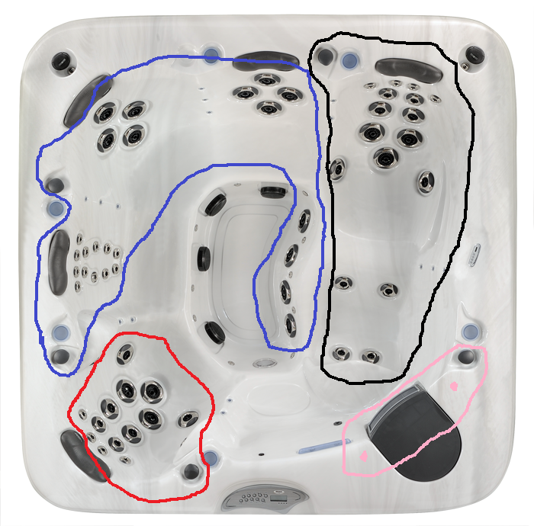
Pump # 1 (red) – air control valve included
Pump #2 (blue) – air control valve included
Pump #3 (black) – air control valve included
Fountain & control valve (pink)

